To: Professor Yuce

Applied Mathematics

New York City College of Technology

From: Brian Holliday

Applied Mathematics

New York City College of Technology

Subject: Lab 9: T-tests; testing the differences between two means; paired t-tests (related samples)

Figure: Distribution of Wilcoxon Scores for Time

Date: 2/25/20

Summary:

For these two datasets we are not sure whether which drug is better or faster acting. We are also not sure if it is coming from the normal distribution so we will use a Wilcoxon Test. This is because of the sample size of our dataset. For the headachepair data, it is most likely dependent because we are keeping track of each of the times by an index. We are going to choose the Wilcoxon Ranked test because we have independent variables that we cannont confirm come from a normal distribution.

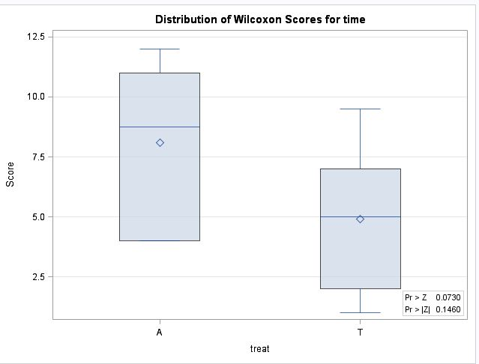

With the p_value more than 0.05, we fail to reject that the distributions are the same. Meaning that we fail to reject that they are equal.